# CS 255 System Design Document Template

Andrei Kourouchin

## UML Diagrams

### UML Use Case Diagram

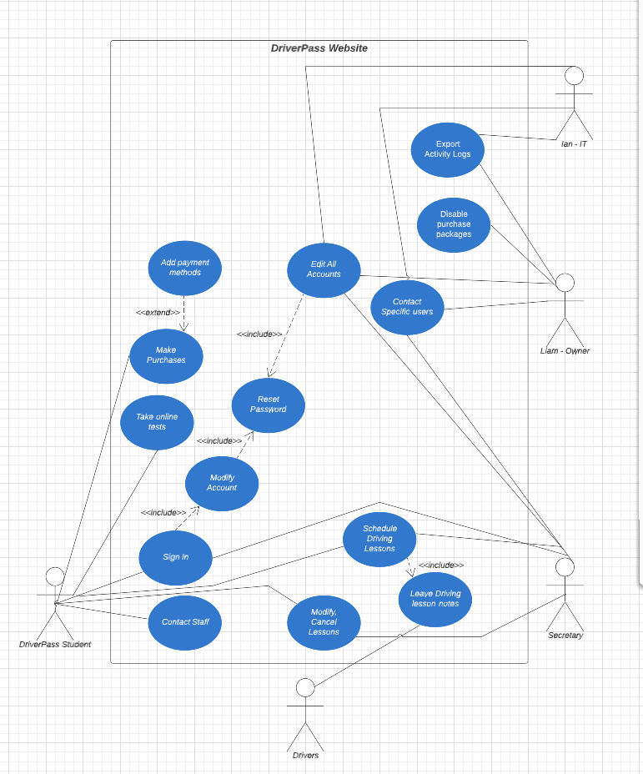

### UML Activity Diagrams

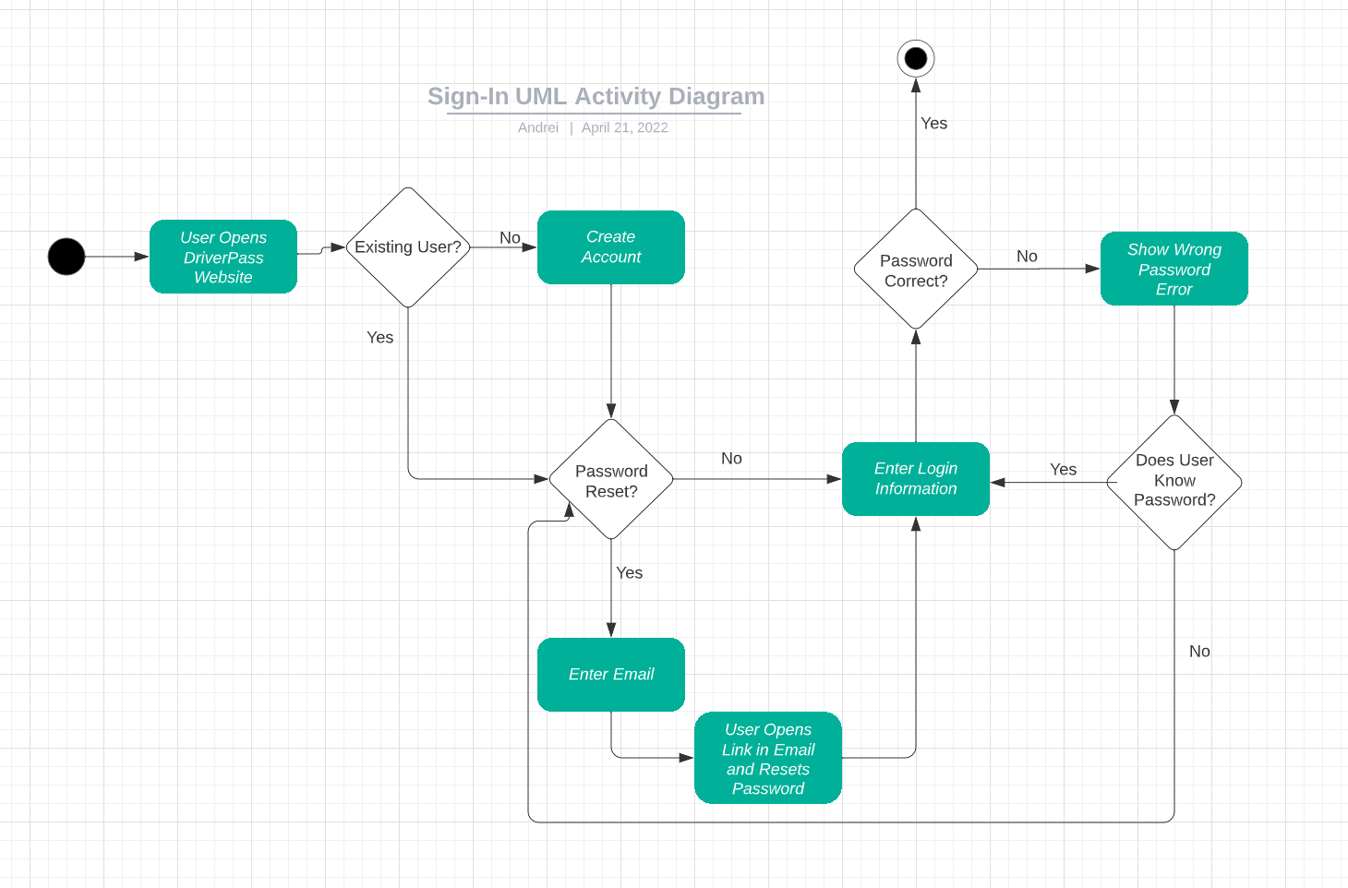

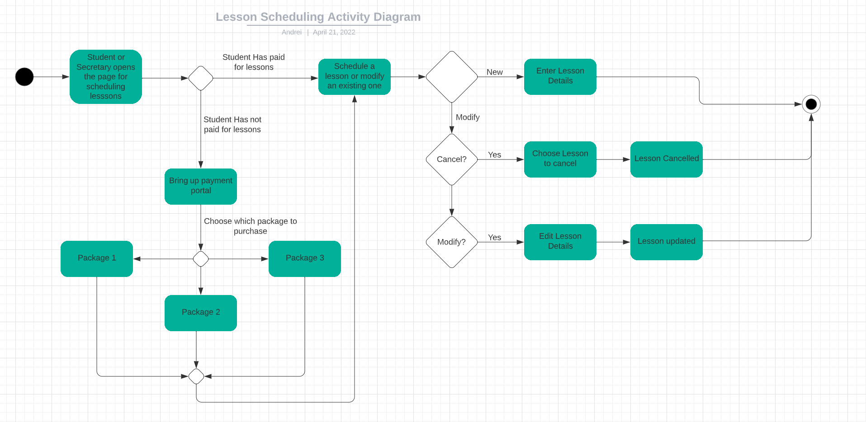

### UML Sequence Diagram

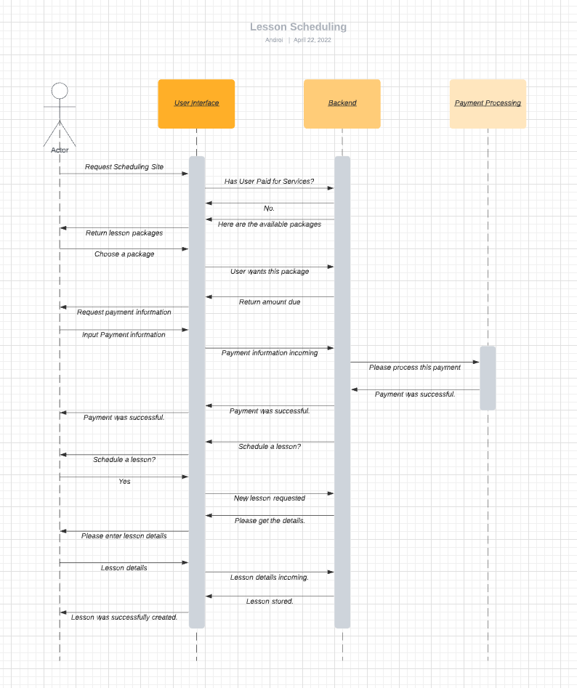

### UML Class Diagram

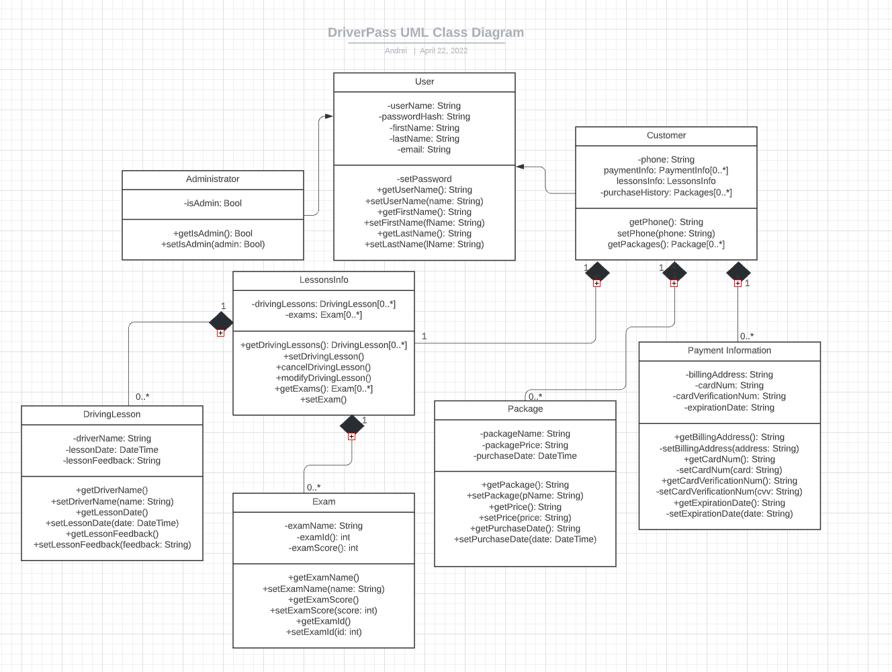

## Technical Requirements

The technical requirements that are required for the design I have created are as follows:

* User Requirements:
  + Any host that allows for a modern web browser such as Google Chrome, Safari, Firefox, or Chromium to run
    - Laptop
    - Desktop
    - Smartphone
    - Tablet
  + High speed internet
* Backend Requirements:
  + Linux cloud servers on AWS
* Payment processing service